Recommended Application List
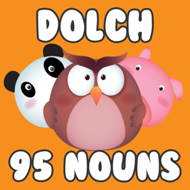  Target Group: Junior and Senior Infants  Cost: Free  Subject Link: Literacy | App Name: 95 Dolch Sight Word Noun Games  Blurb:  This application assists readers, who are at a beginner level, to be capable of determining words instantly. It also assists beginner readers in developing a technique for decoding unknown words that we call 95 Common Dolch Noun Sight Words.
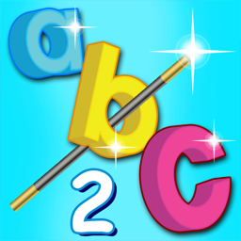  Target Group: Junior Infants - 1st Class  Cost: Free  Subject Link: Literacy | App Name(s): ABC Phonics  (there are 6 progressive apps (1-6) available for downloading).  Blurb:  App 1:This app will help your child learn the sounds of the letters of the alphabet.  App 2:This app will help your child progress with learning the sounds of the letters of the alphabet.  App 3: This app will help your child master the letter sound connection.  App 4: This app will help your child strengthen the association of each letter with its most commonly occurring sound.  App 5: This app will help your child learn how sounds relate to words.  App 6: This app will help your child to reinforce alphabet sound recognition.
Target Group: Junior and Senior Infants  Cost: €4.49  Subject Link: Literacy | App Name: Froggy Match it-Phonics  Blurb:  Froggy Match-it will help your child to develop good reading and spelling skills. It is an educational, interactive phonics game for children just learning to read and is ideal for use in school and at home. The game is designed so that children focus on the reading and spelling tasks. Froggy Match-it uses a step-by-step approach and covers a lot of the phonics learnt at school.
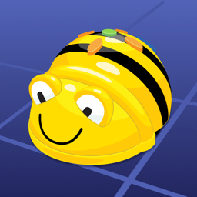  Target Group: Junior and Senior Infants  Cost: Free  Subject Link: Literacy, Maths, SESE (History/Geograpy) | App Name: Bee-Bot  Blurb:  The Bee-Bot app is based on the well-loved Bee-Bot floor robot (which we use for coding at St. Brigid’s G.N.S.). The App makes use of Bee-Bot’s key functionality and enables children to improve their skills in directional language, programming sequences of forwards, backwards, left and right 90 degree turns.
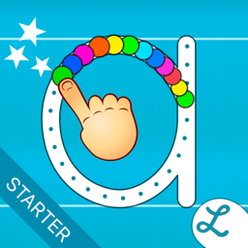  Target Group: Junior and Senior Infants  Cost: Free  Subject Link: Literacy, Numeracy | App Name: Writing Wizard  Blurb:  Writing Wizard is designed to help your child learn how to trace letters, numbers and words through a fun system carefully designed to maintain motivation.
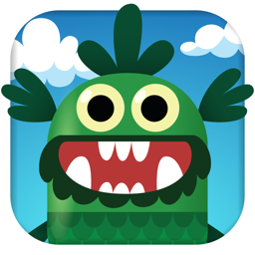  Target Group: Junior and Senior Infants  Cost: Free*****  Subject Link: Literacy, Numeracy | App Name: Teach Your Monster to Read  Blurb:  Teach Your Monster to Read is an award-winning phonics and reading game that’s helped millions of children learn to read. Kids love making their monster and teaching it to read. They learn through play.Children create a monster and take it on a magical journey over three extensive games - meeting a host of colourful characters along the way and improving their reading skills as they progress.  *Highly recommended
Target Group: 1st Class - 4th Class  Cost: Free  Subject Link: Literacy, Numeracy, Gaeilge, SESE | App Name: Scratch JR  Blurb:  With ScratchJr, the children can learn important new skills as they program their own interactive stories and games.By snapping together graphical programming blocks, children can make characters move, jump, dance and sing. In the process, children learn to solve problems, design projects, and express themselves creatively on the computer. They also use maths and language in a meaningful and motivating context, supporting the development of numeracy and literacy.
Target Group: All Class Levels  Cost: Free  Subject Link: Literacy, Gaeilge, SESE (History, Geography, Science) | App Name: Puppet Pals HD  Blurb:  Create your own unique shows with animation and audio in real time! Simply pick out your actors and backdrops, drag them on to the stage and tap record. Your movements and audio will be recorded in real time for playback later. This app is as fun as your own creativity. Act out a story of Pirates on the high seas, fight as scary monsters, or play the part of a Wild West bandit on the loose. You can combine any characters however you want!
Target Group: All Class Levels  Cost: Free  Subject Link: Literacy, Numeracy, SESE | App Name: QR Code Reader by Scan  Blurb:  QR Code Reader is the fastest and most user-friendly QR reader and barcode scanner available. Why not get the children to scan the QR codes located on the various food items in your cupboards? This could prove to be a valuable lesson in nutrition for the children.  You can even challenge yourselves into googling how to create your own QR code together!!
Target Group: All Class Levels  Cost: Free  Subject Link: Literacy, Gaeilge, SESE | App Name: i-Movie  Blurb:  iMovie lets you create Hollywood-style trailers and beautiful movies like never before.Make Hollywood-style trailers. Choose from 14 trailer templates with stunning graphics and original scores by some of the world’s top film composers. Customise movie studio logos, cast names and credits. Select the best videos and photos for your trailer with the help of animated drop zones.
Target Group: All Class Levels  Cost: €5.49  Subject Link: Literacy, Gaeilge, SESE | App Name: Book Creator  Blurb:  Book Creator is the simple way to make your own beautiful ebooks, right on your iPad. Book Creator is ideal for making all kinds of books, including children's picture books, comic books, photo books, journals, textbooks and more.
Target Group: All Class Levels  Cost: Free  Subject Link: Literacy, Gaeilge, SESE | App Name: Adobe Spark Video  Blurb:  Spark Video helps anyone create compelling video stories in minutes. Easily add and trim video clips to make your videos stand out. Pick from over 1 million beautiful iconic images or add your own photos to highlight what you have to say. Select the soundtrack that works best. Then, Spark automatically adds striking cinematic motion to your story.
Target Group: All Class Levels  Cost: Free  Subject Link: Literacy, Gaeilge, SESE | App Name: Comic Touch 2  Blurb:  Comic Touch 2 is used for creating comics out of your pictures. Swipe through templates while in the camera mode to see exactly what your comic layout will look like before you take the picture. Add your own balloons, comic lettering and captions to the templates with a tap.

Recommended Website List
Web Address:  http://www.pobble365.com/  Quick Link Scan:  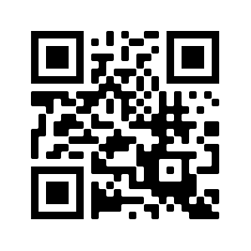  Target Group: 1st Class-6th Class  Subject Link: Literacy (Creative Writing) | Website Name: Pobble 365  How This Website can be Used for Learning:  - Select an image (there are many).  - If the image itself doesn’t spark a thousand ideas, simply scroll down and use the activities provided.  - Use the photographs as they are or as a starting point for something even bigger.  - Start your creative piece of writing.
Web Address:  www.worldbook.com  Quick Link Scan:  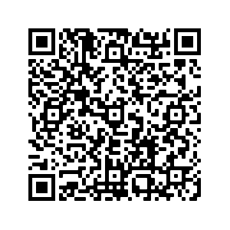  Target Group: Junior Infants-6th Class  Subject Link: All curriculum areas | Website Name: World eBook  How This Website can be Used for Learning:  - World Book Online have just made their collection of over 3,000 ebooks and audiobooks available for free for children to access at home.
Web Address:  www.topmarks.co.uk  Quick Link Scan:  Target Group: Junior Infants-6th Class  Subject Link: All curriculum areas | Website Name: Topmarks  How This Website can be Used for Learning:  - Topmarks is a leading independent educational website for children,teaching professionals and parents.  - This website provides game based opportunities for learning across all curricular areas and class levels.
Web Address:  www.gonoodle.com  Quick Link Scan:  Target Group: Junior Infants-6th Class  Subject Link: Physical Education/SPHE/Digital Learning | Website Name: Go Noodle  How This Website can be Used for Learning:  - Go Noodle provides opportunities for all children to get active with movement and mindfulness videos which have been created by child development experts.
Web Address:  www.mathsframe.co.uk  Quick Link Scan:  Target Group: Second Class-6th Class  Subject Link: Numeracy, Digital Learning | Website Name:  Maths Frame  How This Website can be Used for Learning:  - Mathsframe has more than 200 interactive maths games and 300 maths worksheets and assessments linked to all strands of the curriculum.
Web Address:  www.worldbookonline.com  Quick Link Scan:  Target Group: 1st Class-6th Class  Subject Link: All curricular areas | Website Name:  World Book Online  How This Website can be Used for Learning:  - World Book is a leading publisher of nonfiction and mixed-genre children's book series.  - Through interacting with this website, the children would be provided with fantastic opportunities for integration into multiple curricular areas such as literacy, SESE etc.
Web Address:  www.twinkl.ie  This website is FREE for one month. Use the code IRLTWINKLHELPS to get free access for one month.  Quick Link Scan:  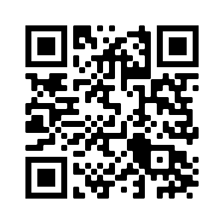  Target Group: Junior Infants-6th Class  Subject Link: All curricular areas | Website Name:  Twinkl  How This Website can be Used for Learning:  - Twinkl is a popular website used by all teachers.  - The website provides fabulous resources which cater for all age groups, across all curricular areas.  PLEASE NOTE:  TWINKL HAVE CREATED SCHOOL CLOSURE PACKS WHICH CATER FOR EACH CLASS LEVEL.
Web Address:  www.amathsdictionaryforkids.com  Quick Link Scan:  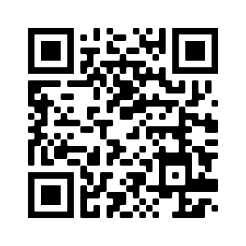  Target Group: Junior Infants-6th Class  Subject Link: Numeracy, Digital Learning | Website Name:  A Maths Dictionary for Kids  How This Website can be Used for Learning:  - The original A Maths Dictionary for Kids is an animated, interactive online math dictionary for students which explains over 630 common mathematical terms and math words in simple language with definitions, examples, activities, practice and calculators.
Web Address:  https://www.literacyshed.com/  Quick Link Scan:  Target Group: 1st Class-6th Class  Subject Link: Literacy, Digital Learning | Website Name:  The Literacy Shed  How This Website can be Used for Learning:  - This website provides high quality resources that can be used in stand alone literacy lessons, can form the basis for a whole Literacy unit or can support literacy units.  - With the many book based activities, using the book alongside the digital resource, is advocated.
Web Address:  www.cula4.com  Quick Link Scan:  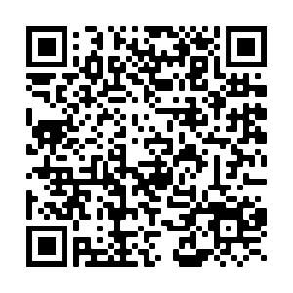  Target Group: 1st Class-6th Class  Subject Link: Gaeilge | Website Name:  Cúla 4  How This Website can be Used for Learning:  - Cúla4 is an Irish language programming block and a stand-alone television channel for Irish speaking children in the Republic of Ireland and Northern Ireland. It is operated by TG4.
Web Address:  www.hourofcode.com/ie  Quick Link Scan:  Target Group: 2nd Class-6th Class  Subject Link: Numeracy, Digital Learning | Website Name:  Hour of Code  How This Website can be Used for Learning:  - The Hour of Code started as a one-hour introduction to computer science, designed to demystify "code", to show that anybody can learn the basics, and to broaden participation in the field of computer science.  - Hour of Code activities are self-guided.  - Code.org tutorials work on all devices and browsers.
Web Address:  https://trte.rte.ie/news2day/  Quick Link Scan:  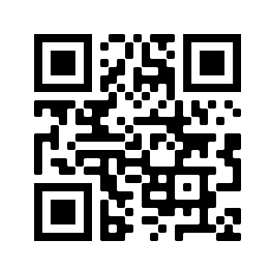  Target Group: 1st Class-6th Class  Subject Link: All curricular areas | Website Name:  News2Day  How This Website can be Used for Learning:  - News2Day takes a child-friendly approach to providing your children with appropriate news updates.  - This resource can be used as an opportunity for creative writing.
Web Address:  https://www.bbc.co.uk/bitesize/topics/zf2f9j6/articles/z3c6tfr  (Google BBC Dance Mat)  Quick Link Scan:  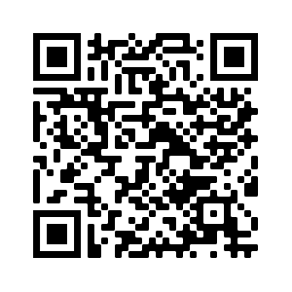  Target Group: 1st Class-6th Class  Subject Link: Digital Learning | Website Name:  BBC Dance Mat (a branch of the BBC Bitesize webpage)  How This Website can be Used for Learning:  - BBC Dance Mat is a typing programme which consists of various levels that the children can progress through.  - It supports the development of typing skills.
Web Address:  www.cosmicyogakids.com  Quick Link Scan:  Target Group: Junior Infants-6th Class  Subject Link: SPHE/Wellbeing/Physical Education/Digital Learning | Website Name:  Cosmic Yoga for Kids  How This Website can be Used for Learning:  - Cosmic Yoga promotes mindfulness, physical activity and relaxation. It is designed specially for kids aged 3+ and can be used in schools and homes all over the world.  - Simply press play and the instructors will guide the children through the yoga sessions.  - Additional resources are also available on the website.
Web Address:  https://www.bbc.co.uk/bitesize  Quick Link Scan:  Target Group: 1st Class-6th Class  Subject Link: Literacy/History/Geography/Science | Website Name:  BBC Bitesize  How This Website can be Used for Learning:  - BBC Bitesize provides interactive and printable resources for all age levels across all subject areas.  - It is favoured by teachers for History, Geography and Science lessons.
Web Address:  https://rtejr.rte.ie/10at10/  Quick Link Scan:  Target Group: Junior Infants-6th Class  Subject Link: Physical Education/SPHE (Wellbeing) | Website Name:  RTE Junior 10 @ 10  How This Website can be Used for Learning:  - 10 minute bursts of physical activity are enacted on this website.  - Each exercise video is different.  - Each video is led and each exercise is modelled by two practitioners.  - Each video lasts 10 minutes.
Web Address:  http://www.iamanartist.ie/  Quick Link Scan  Target Group: Junior Infants - 6th Class  Subject LInk: Visual Arts | Website Name: I am an Artist  How this website can be used for Learning:  I Am An Artist is a visual arts initiative aimed at supporting the adoption and delivery of the primary visual arts curriculum in Ireland. By comprising 30 short TV programmes (each 6 minutes in length), an interactive website with slideshows, lessons, weblinks and interactive games, it provides a stimulating collection of curriculum-mapped resources.
Web Address:  https://dabbledoomusic.com/p/parents  Quick Link Scan:  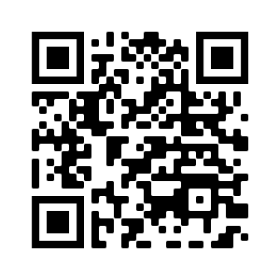  Target Group: Junior Infants - 6th Class  Subject Link: Music | Website Name: Dabbledoo Music  How this website can be used for Learning:  DabbledooMusic makes music education more accessible, engaging and fun for teachers and students . Resources have been developed to help teachers and schools cover all areas of the primary school curriculum, in a way that promotes creativity and collaboration and instills a lifelong love of music.
Web Address:  https://www.classicsforkids.com/  Quick Link Scan:  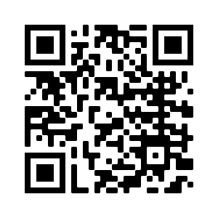  Target Group: Junior Infants to Sixth Class  Subject Link: Music | Website Name: Classic for Kids  How this website can be used for Learning:  This website helps children to learn all about classical music through engaging activities and musical games.

